Assignment 9.3 : Practicing the relational operators in PIG by following the steps shown in the given blog.

1. LOAD

2. LIMIT

3. ORDER BY

4. GROUP BY

5. FOREACH

6. FILTER

7. STORE

1. LOAD

You can load data into Apache Pig from the file system (HDFS/ Local) using LOAD operator of Pig Latin.

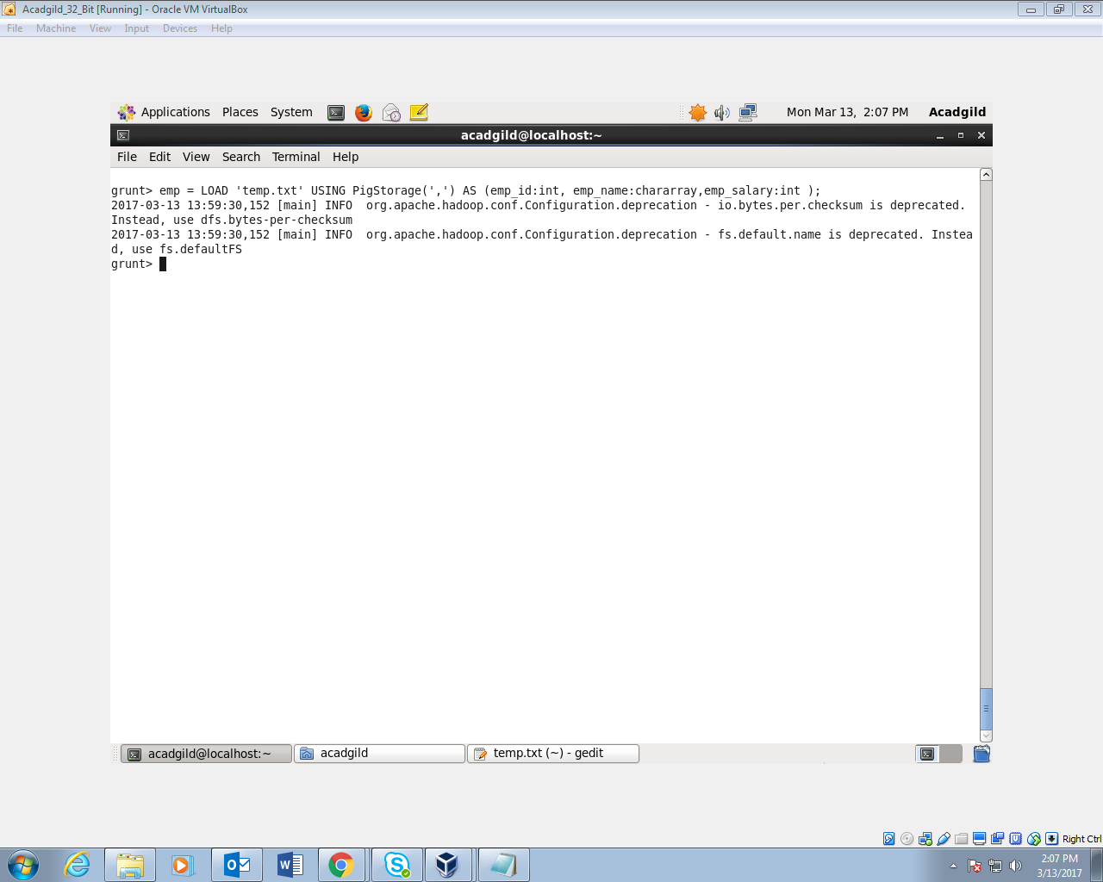

1. LIMIT

Used to limit the number of outputs to the desired number.

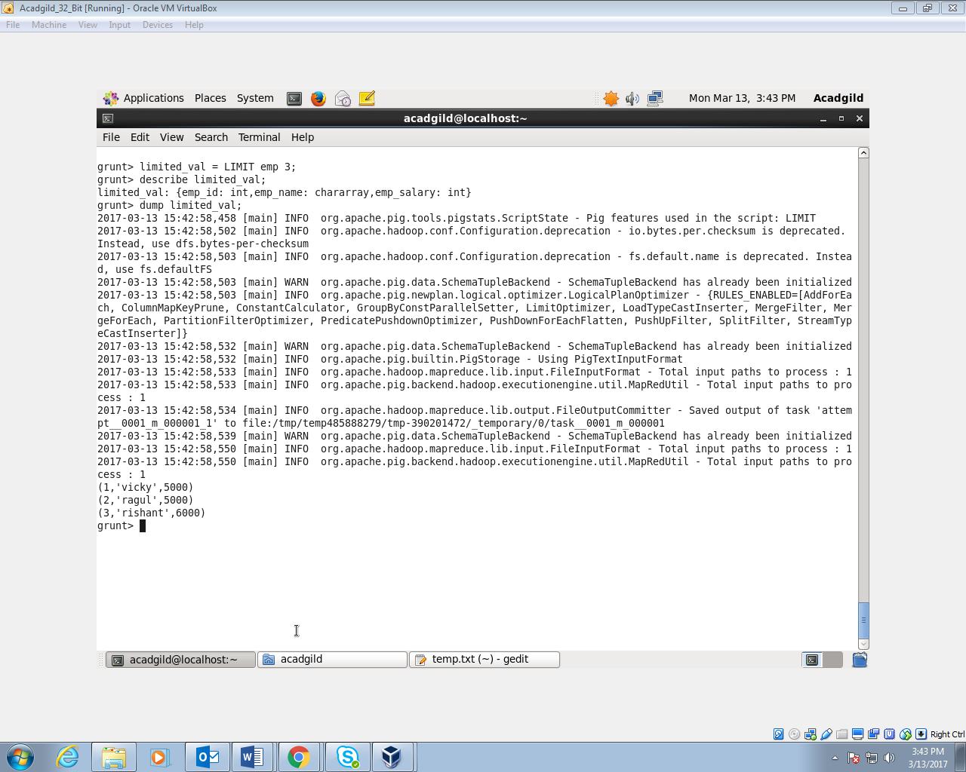

1. ORDER BY

The ORDER BY operator is used to display the contents of a relation in a sorted order based on one or more fields.

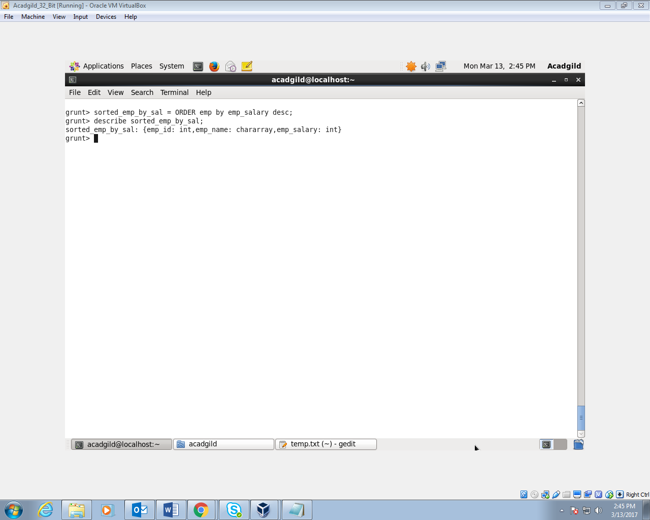

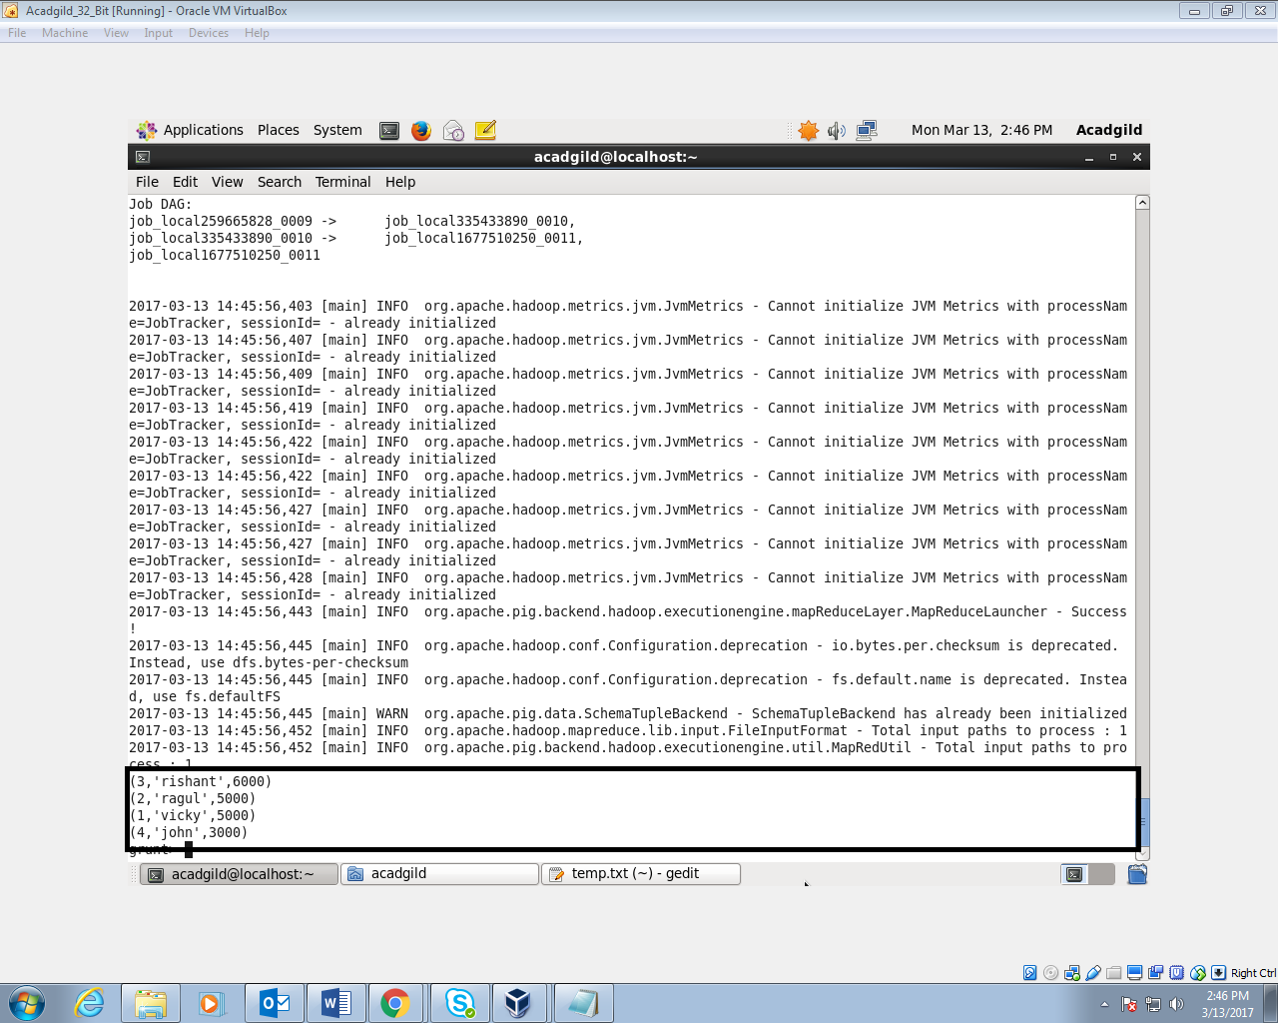

1. GROUP BY

The GROUP operator is used to group the data in one or more relations. It collects the data having the same key.

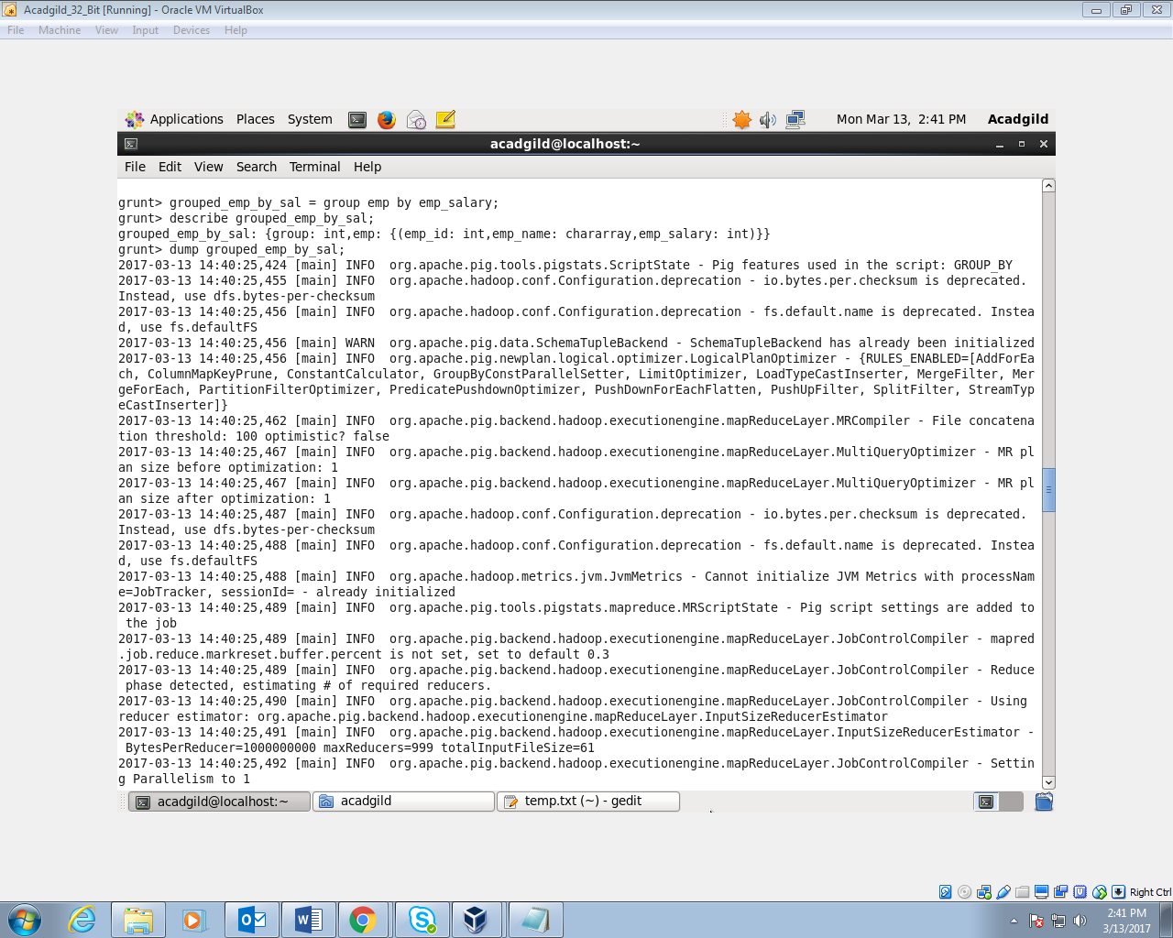

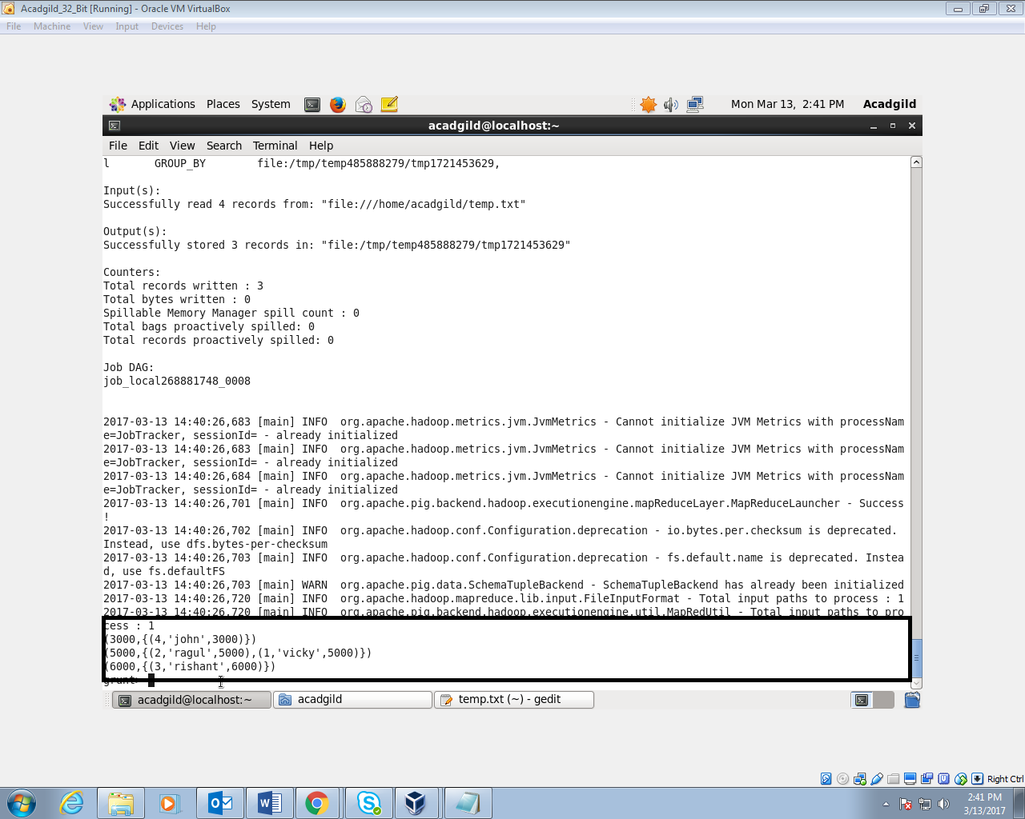

1. FOREACH

The FOREACH operator is used to generate specified data transformations based on the column data.

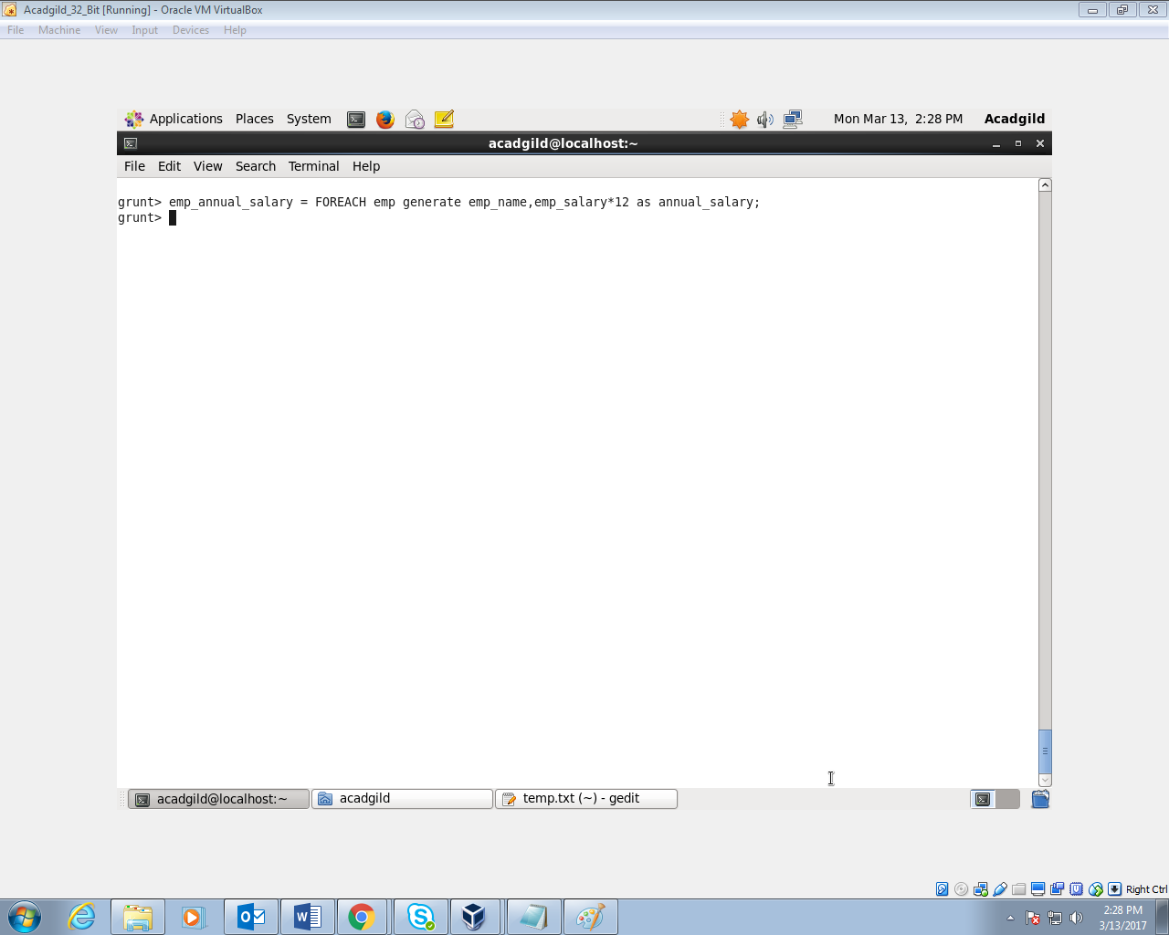

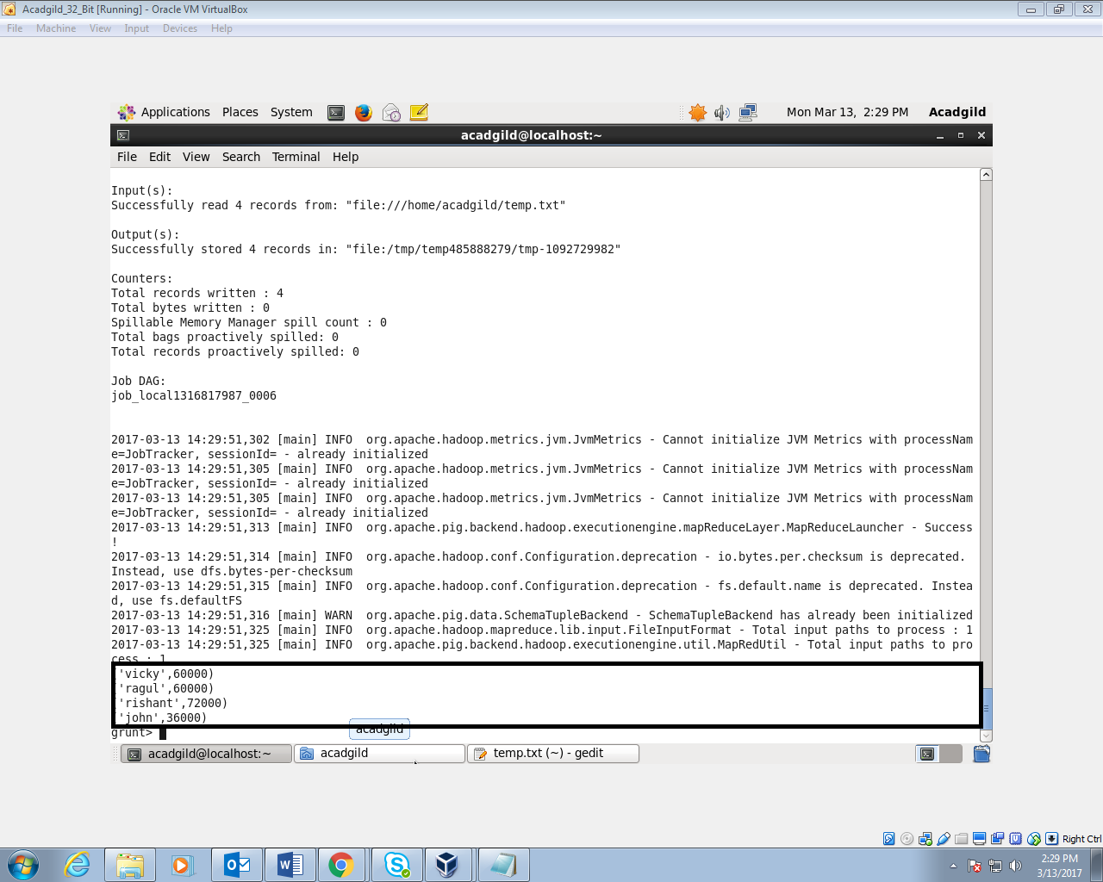

1. FILTER

The FILTER operator is used to select the required tuples from a relation based on a condition.

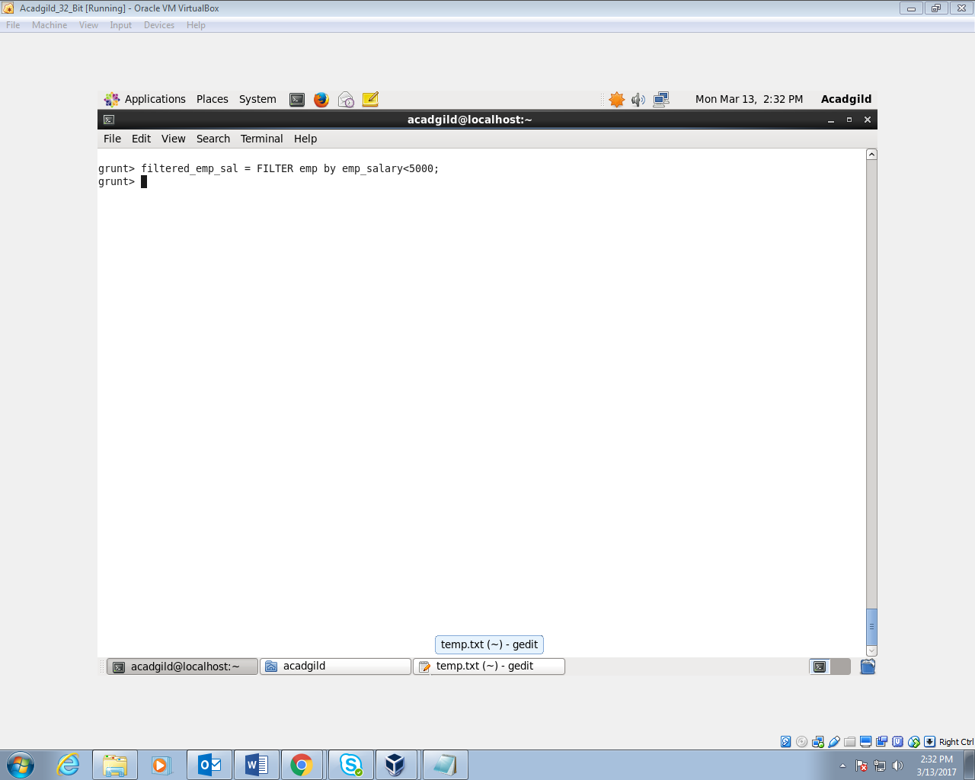

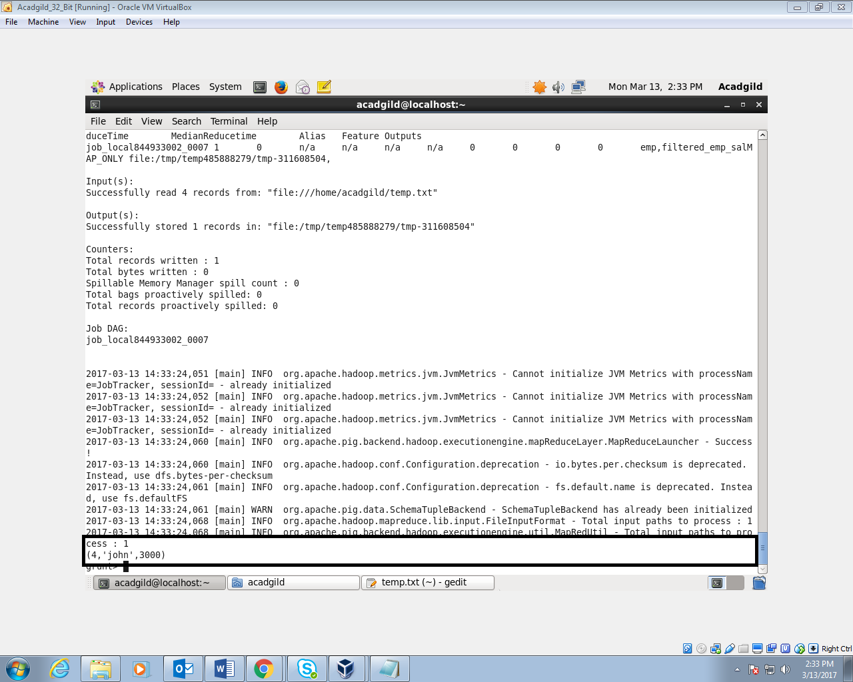

1. STORE

You can store the loaded data in the file system using the store operator.

